
National Universityof Computer and Emerging sciences
Objectives:
- To learn the implementation of Boolean function using multiplexer
- To learn how to implement Multiplexers using decoders

2x1 MUX:
74LS157 IC is a dual 4x1 MUX with active low enable.
STROBE (Enable) | SELECT | A | B | Y (o/p for LS157) | Y (o/p for LS158)
H | X | X | X | L | H
L | L | L | X | L | H
L | L | H | X | H | L
L | H | X | L | L | H
L | H | X | H | H | L
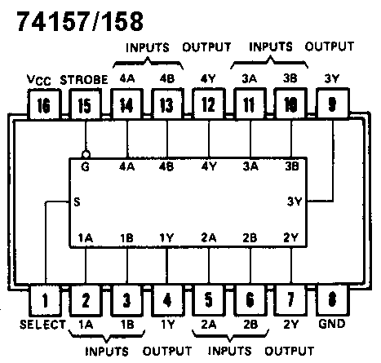

4x1 MUX:
74LS153 IC is a dual 4x1 MUX with active low enables. Two 4x1 MUXs with common selection pins but independent inputs and independent outputs is known as dual 4x1 MUX. The function table and connection diagram for this IC are shown below:

Function Table:

Strobe (Enable) | Selection Inputs |  | Data Inputs |  |  |  | Output
G | B | A | C0 | C1 | C2 | C3 | Y
H | X | X | X | X | X | X | L
L | L | L | L | X | X | X | L
L | L | L | H | X | X | X | H
L | L | H | X | L | X | X | L
L | L | H | X | H | X | X | H
L | H | L | X | X | L | X | L
L | H | L | X | X | H | X | H
L | H | H | X | X | X | L | L
L | H | H | X | X | X | H | H

H= Logic High, L= Logic Low, X= Don’t Care

Connection Diagram:

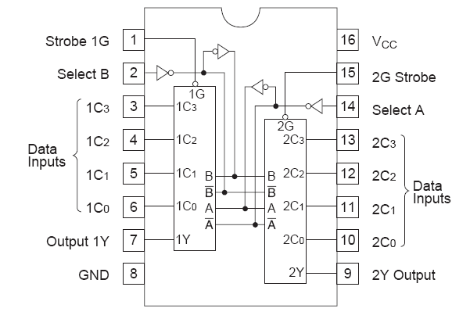

2-to-4 line decoders:
74LS139 IC contains two fully independent 2-to-4 line decoders with active low enables. The function table and connection diagram for this IC are shown below:
Function Table:
Enable | Selection Inputs |  | Outputs
G | B | A | Y0 | Y1 | Y2 | Y3
H | X | X | H | H | H | H
L | L | L | L | H | H | H
L | L | H | H | L | H | H
L | H | L | H | H | L | H
L | H | H | H | H | H | L

H= Logic High, L= Logic Low, X= Don’t Care
Connection Diagram:
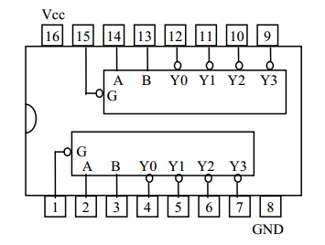

Lab Tasks
Question 1:Implement the following on logic trainer function using 4x1 mux
F (X, Y, Z) = m1 + m2 + m6 + m7
Question 2: Implement the following on logic works:
Full adder circuit using 4x1 (dual) MUX
Question 3:Implement the following on logic works
4x1 MUX using one 2x4 decoder, four ANDs and one OR gate

Quiz
Design and implement a decoder/combinational circuit that accepts 3 bit number as input and generates an output of its square showing the result in 6 bits. .

